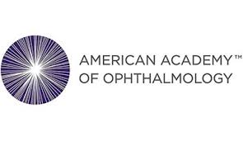
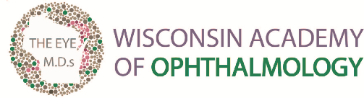

Contact: February 13, 2023
Eric Ostermann, Association Director
(920) 560-5645; or wao@badgerbay.co

New Research Suggests Alcohol May Not Be Safe for People with Age-related Macular Degeneration

Moderate to high alcohol consumption may raise incidence of early AMD, warn the Wisconsin Academy of Ophthalmology and the American Academy of Ophthalmology

Kimberly, WI – Even though Dry January is over, new research suggests you may want to consider keeping the no-alcohol challenge going all year, especially if you’re among the nearly 2 million Americans who have age-related macular degeneration (AMD), a sight-threatening eye condition, caution the Wisconsin Academy of Ophthalmology and the American Academy of Ophthalmology.

A recent study published in Current Eye Research evaluated seven studies looking at the relationship between alcohol consumption and AMD. The researchers found that moderate to high alcohol consumption was linked to a higher incidence of early AMD, compared with people who didn’t drink or who drank occasionally.

“Age-related macular degeneration (AMD) is a leading cause of vision loss in aging Americans, but fortunately there are steps individuals can take to prevent this serious eye disease,” said David Nash, M.D, President of the Wisconsin Academy of Ophthalmology. “You can reduce your risk of AMD by implementing a handful of simple lifestyle changes, including a healthy diet, regular exercise, quitting smoking, and scheduling regular medical eye exams. It has also become clear that limiting alcohol use can help prevent AMD.”

Why should people with AMD or at risk of developing AMD be concerned about alcohol consumption? AMD is the most common cause of blindness in Americans over the age of 50, affecting about 2.1 million people nationwide. As the population ages, the estimated number of people with AMD is expected to more than double to 5.44 million by 2050.

AMD is a degenerative disease that damages the macula, part of the retina responsible for central vision. Over time, the loss of central vision can interfere with everyday activities, such as the ability to drive, read, and see faces clearly.

While genetics do play a part in the development of AMD, there are several lifestyle choices you can make to decrease your chances of losing vision to AMD, including:

- Healthy eating. Ever heard the old saying about carrots being good for the eyes? It’s true. So are leafy greens, colorful fruits and vegetables, and fatty fish. Eating a vitamin-rich diet can help protect your vision against age-related macular degeneration and other eye diseases.
- Manage your body weight and overall health. Hypertension, high cholesterol, and heart disease are all risk factors for age-related macular degeneration. Exercise is a good way to combat some of these health risks.
- Don’t smoke. Studies show smokers are more likely to get eye diseases including AMD, compared with people who never smoked.
- Get your eyes dilated by an ophthalmologist. During this routine exam, an ophthalmologist will be able to spot eye diseases early — sometimes before you notice any symptoms — and get you the best care to protect your vision. The American Academy of Ophthalmology recommends all healthy adults get a comprehensive eye exam by age 40 to screen for blinding eye diseases.

“We already knew that lifestyle choices can help prevent AMD,” said Dianna Seldomridge, M.D., clinical spokesperson for the American Academy of Ophthalmology. “Now we also know that alcohol consumption may be another modifiable risk factor we can control to lower the risk of developing this potentially blinding eye disease.”

For more information about eye health, visit the Academy’s EyeSmart website.

About the Wisconsin Academy of Ophthalmology
The Wisconsin Academy of Ophthalmology (WAO) is a professional medical society comprised of Wisconsin ophthalmologists (medical eye doctors) who are committed to promoting quality eye care for the citizens of Wisconsin by providing its members with resources including professional education, legislative advocacy, and membership services to enhance the practice of ophthalmology in Wisconsin.

###

